Peter Victoratos

CSC 411

Homework 1: Restoring the Russian Empire

1. Introduction

This homework assignment was centered around the method that Russian chemist Sergei Mikhailovich Prokudin-Gorskii used to create color images before computers could process color. In the same fashion as his work, I replicated the splitting, adjusting and merging of the images to process a colored image.

1. Method

I first completed the **translate** and **compute_ssd** functions to shift the pictures to and compare their sum of squared differences (ssd) values. The translate function was just copied from my Lab02.py file since the translation is done the same way. Computing the ssd was done with no loops, just np functions. I was able to convert the two images being input into arrays that were then subtracted, squared and then added finally. These values allow the **align_images** function to repeatedly test offset values until the three layers are aligned as best as possible. It does so by running the two input images through a loop that keeps translating the second image until the lowest ssd value is found. Once this is done for both the green and red channels (since the blue one is used for reference), the images are merged and the full color image is returned.

I also completed one of the challenges which included taking my own photos. To do so I created a small paper sleeve that sits on my camera lense. I then took a three pictures of the same subject with a blue, green and red clear filter over the lense. This created three images that represent their respective color channels. I stacked these images on top of each other and ran the algorithm. These pictures are towards the end of the results section.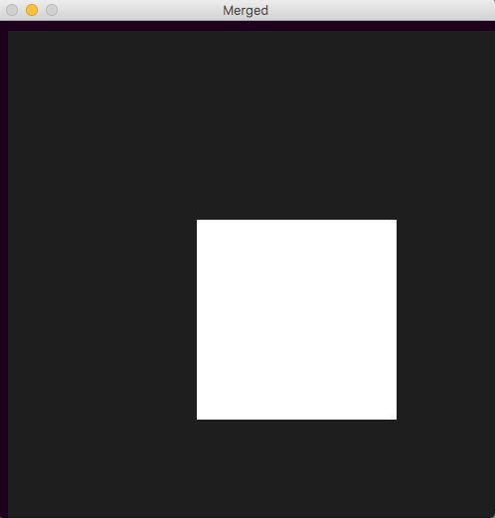

1. Results

**Test.jpg** works regularly, aligning the channels so that only a white square is left. (Test.jpg is to the right)

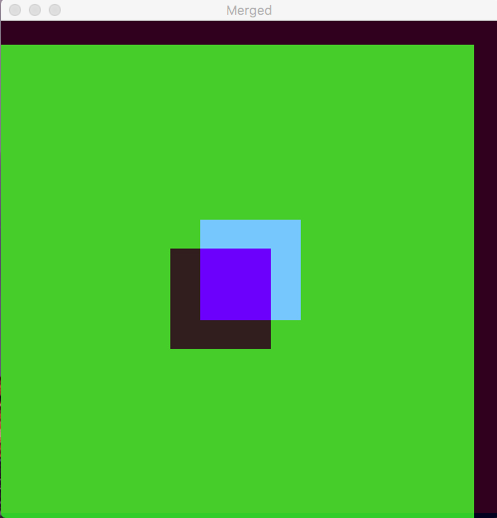

**Test2.jpg** (left) does not align correctly. I believe is this because the program compares three images that have drastically different values. The middle image (green) has the highest values so it skews the ssd values. So when the images are finally being aligned, the two alignment functions that were called were way off from each other.

**Tobolsk.jpg** worked pretty well. It would have been better if I had a crop function to remove the annoying borders.

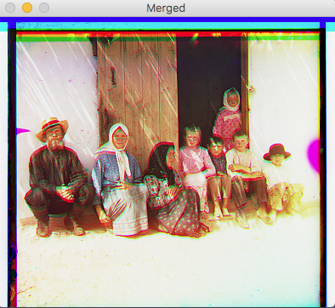

**Settlers.jpg** has some distortion to it

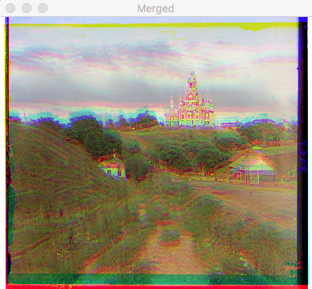

**Cathedral.jpg** does no align the channels perfectly either

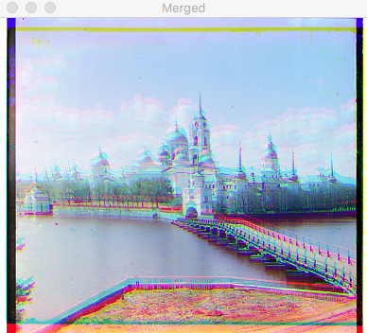

**Monastery.jpg** probably gives the coolest distortion of the images. I feel these past three images are kind of small in size so my basic function cannot compare it to the minute level of detail needed to align them properly. Below are a couple archive images I tried. Not too bad.

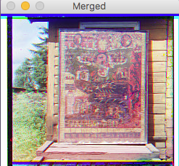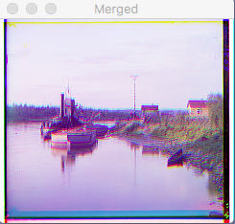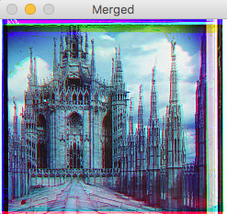

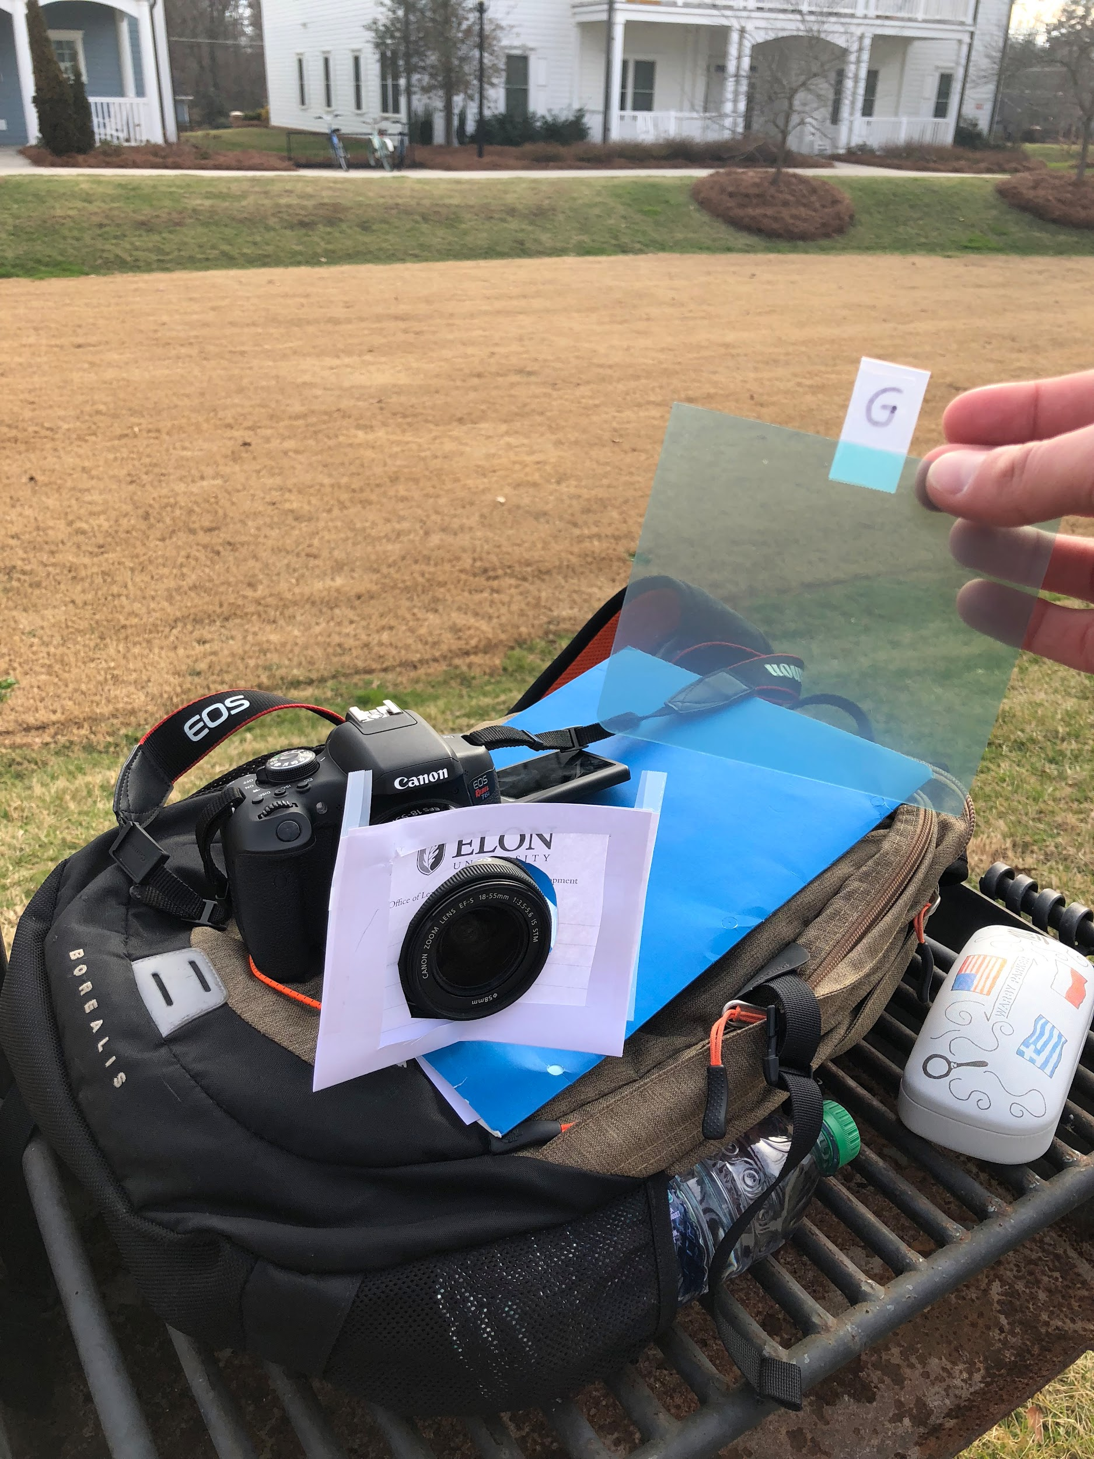

What I failed to do for my own pictures was offset the three stacked images. So when I ran the image through my algorithm, it just merged the images and gave me this green tint to my image. This image took such a long time to process since it is three large images stacked. This will take long regardless of the offset value.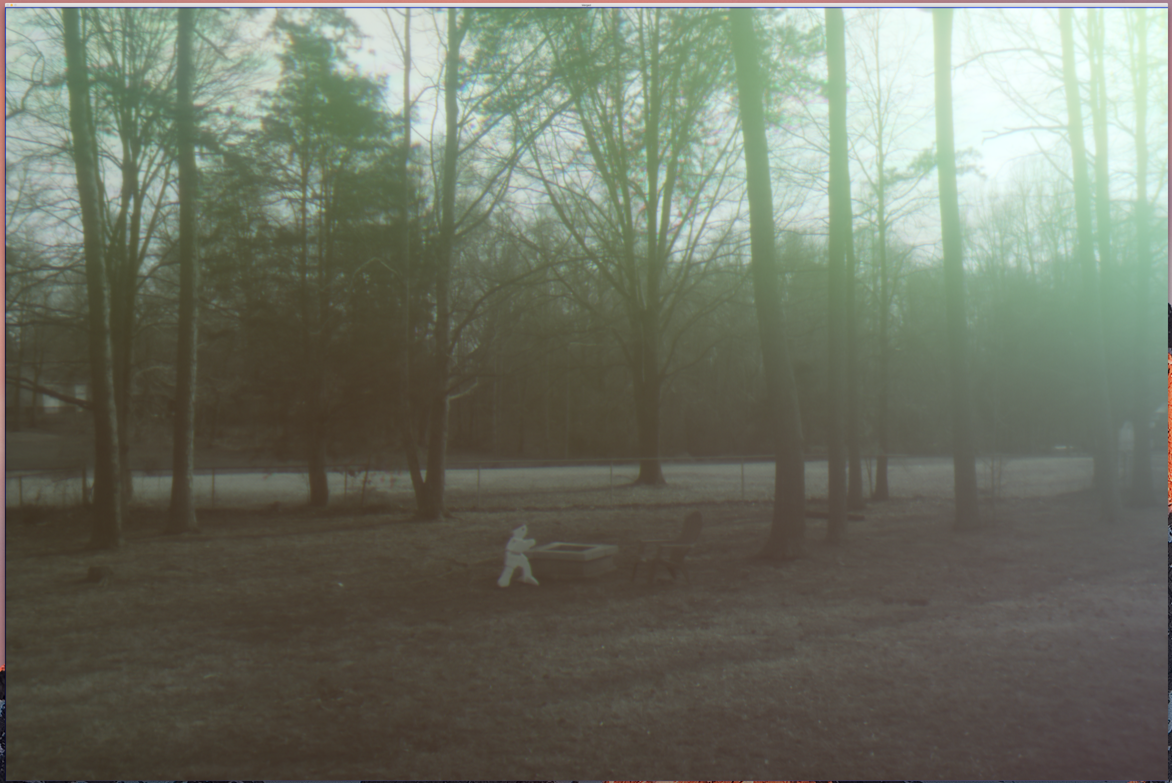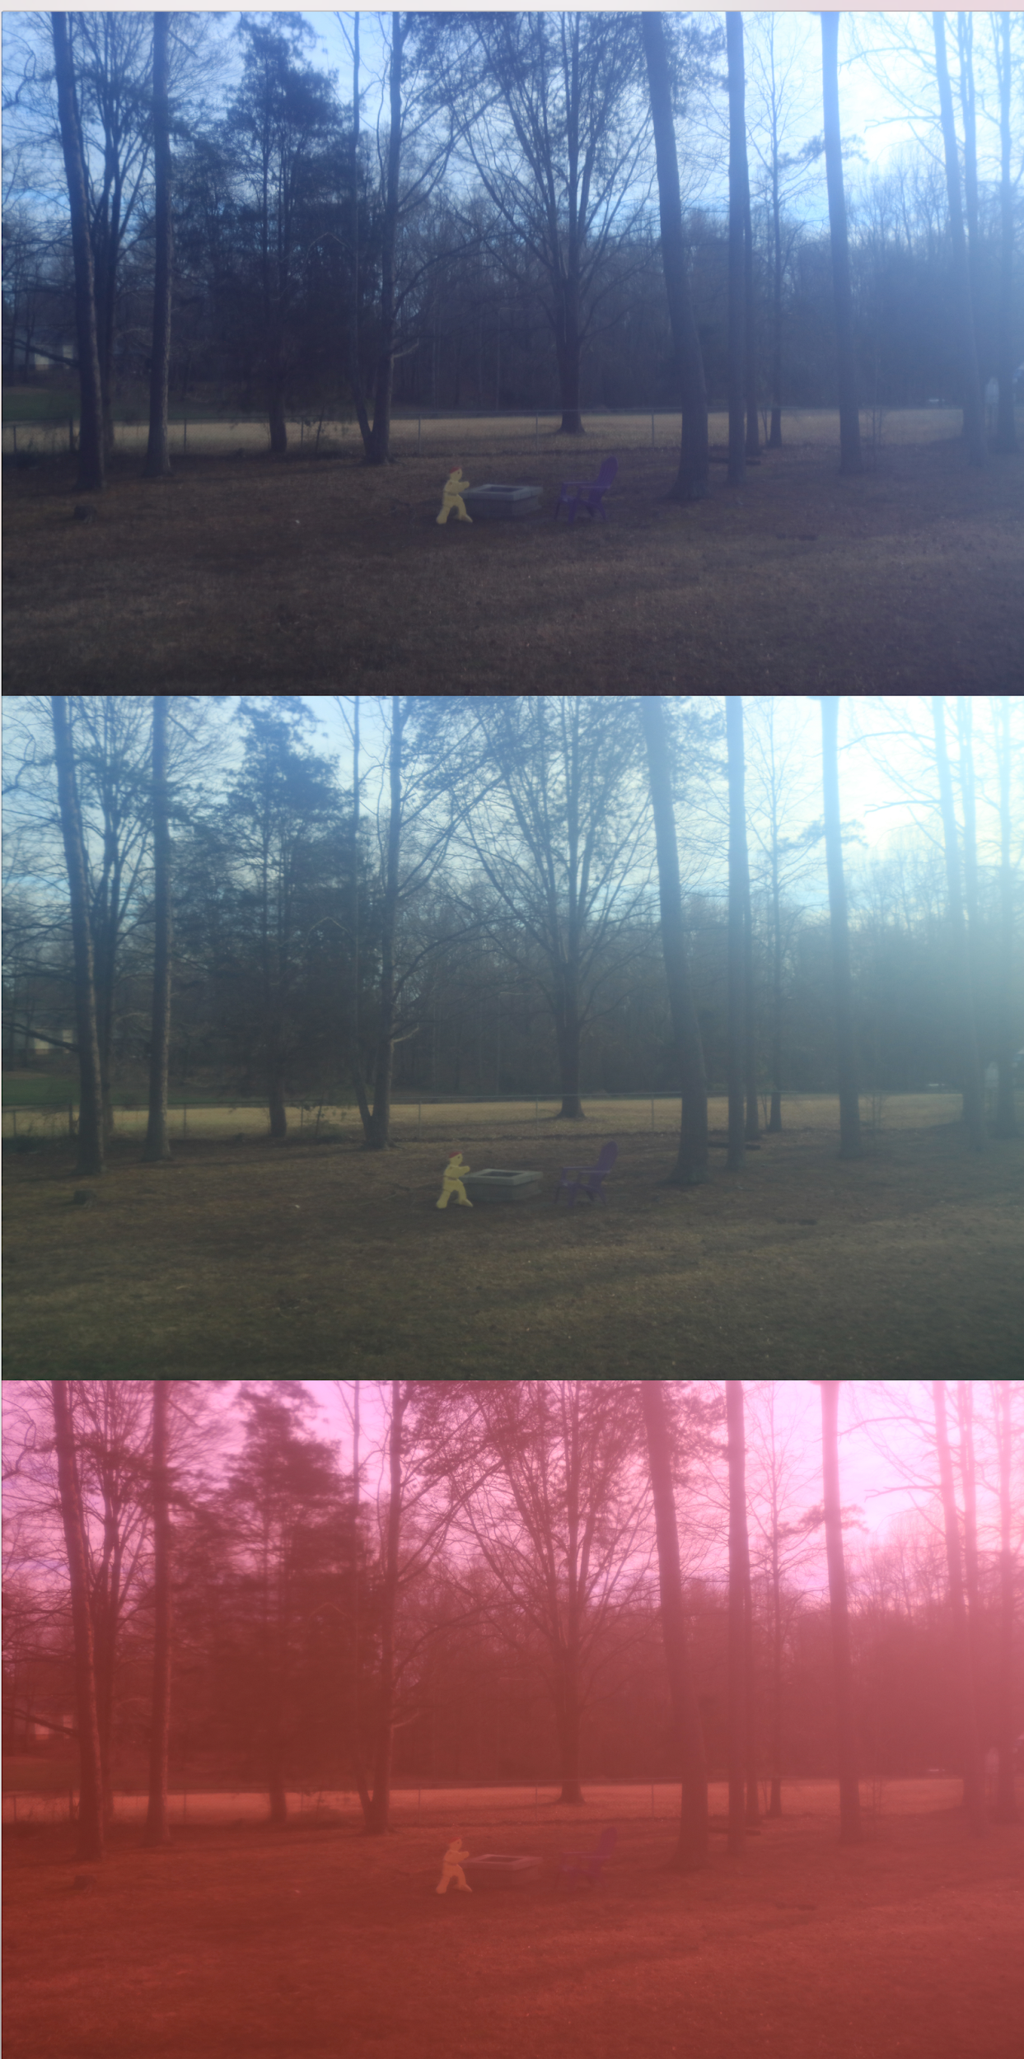

4. Conclusion: Based upon my results I would say that my program works pretty well. It has a simple align function that can handle smaller images with lower pixel densities. It seems that images that had high blue values worked the most. I believe this is the case since blue does not get translated at all, so it has the least amount of distortion from the desired image.

As I was programming I also skipped around a lot without running proper tests. This definitely slowed my work down. If I had debugged earlier I felt that cropping the images would have made them look better. However I am happy with the distorted images, they look really cool. I am definitely going to continue playing around with this function so I can edit photos using a program I wrote. (That’s a cool thing to say)